[Date]
Manoj Sai
Pratian Technologies
Provider Information integration and Verification System

American Nurses Credentialing Centre

The mission of the American Nurses Credentialing Center (ANCC), a subsidiary of the American Nurses Association (ANA), is to promote excellence in nursing and health care globally through credentialing programs. ANCC's internationally renowned credentialing programs certify and recognize individual nurses in specialty practice areas.
ANCC Work Flow
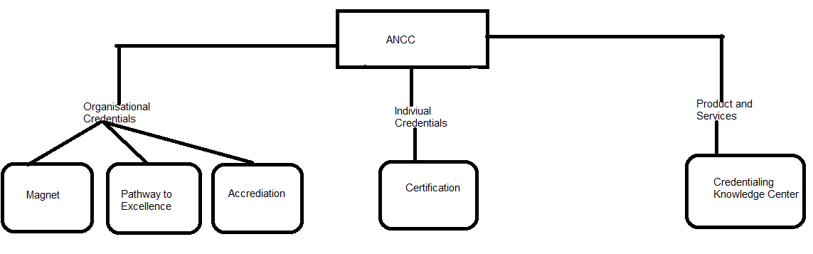
- Magnet Recognition Program: It is the most prestigious distinction a health care organization can receive for nursing excellence and quality patient outcomes
- Pathway: It recognizes a healthcare organisation’s focus mainly having good practicing nursing environment, career development.
- Accreditation Program: It ensures the quality of nurse education program (CNE) and skills based competency programs.
- Certification Program: It is to certify nurses with professional practices according to the latest nursing practice standards.
- ISO: ANCC is the only nursing organisation to achieve ISO 9001:2008 certification
ANCC as Credentialing
- Total number of nurses in US are : 3,963,844.
- ANCC is the largest nursing credentialing organization in the world.
- ANCC offers four credentialing programs/Services :
- Board Certification (25 programs, including 12 in advanced practice).
- Magnet Recognition Program.
- Pathway to Excellence recognition.
- Accreditation
- Accreditation of continuing nursing education organizations.
- Accreditation of courses to validate a nurse’s skills or skill sets in the clinical setting (Nursing Skills Competency Program).
- Joint accreditation for continuing education providers with the Accreditation Council for Continuing Medical Education and Accreditation Council for Pharmacy Education.
- Certification Exams
Certifications Available

Interprofessional Certifications
- National Healthcare DisasterCertification

Nurse Practitioner Certifications
  - Acute Care NP
  - Family NP
  - Adult Nurse NP
  - Gerontological NP
  - Adult-gerontological Acute Care NP
  - Adult-gerontological Primary Care NP
  - Adult Psychiatric-Mental Health NP
  - Pediatric Primary Care NP
  - Psychiatric – Mental Health NP
  - School NP
- Clinical Nurse Specialist Certifications
  - Adult Health CNS
  - Gerontological CNS
  - Adult Gerontological CNS
  - Home Health CNS
  - Adult Psychiatric Mental Health CNS
  - Child/Adolescent Psychiatric – Mental Health CNS
  - Pediatric CNS
  - Public Community Health CNS
- Specialty Certifications
  - Ambulatory Care Nursing
  - General Nursing Practice
  - Nursing Case Management
  - Cardiac Rehabilitation Nursing
  - Advanced Genetics
  - Nursing Professional Development
  - Cardiac-Vascular Nursing
  - Gerontological Nursing
  - Pain Management Nursing
  - Certified Vascular Nurse
  - Hemostasis Nursing
  - Pediatric Nursing
  - College Health Nursing
  - Home Health Nursing
  - Perinatal Nursing
  - Community Health Nursing
  - Informatics Nursing
  - Psychiatric Mental Health Nursing
  - Diabetes Management Advanced
  - Medical-Surgical Nursing
  - Advanced-Public Health Nursing
  - Faith Community Nursing
  - Nurse Executive
  - Rheumatology Nursing
  - Forensic Nursing-Advanced
  - Nurse Executive-Advanced
  - School Nursing

